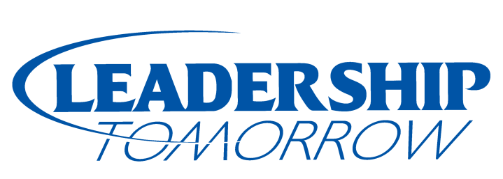

Mission

Hall County Leadership Unlimited, Inc. identifies and educates proven and potential leaders who are committed to developing and utilizing positive leadership skills to improve our community.

Leadership Tomorrow Class #34

Alec Anania Five Points Bank
Travis Arnold Almquist, Maltzahn, Galloway & Luth
Logan Belville Bosselman Enterprises
Jen Bernth Hope Harbor
Michael Bogner Congressman Adrian Smith
Jerry Brown Reliv International
Jaden Butler Equitable Bank
Jessica Campos Wells Fargo Bank
Bethany Guzinski Woods Brothers Realty
Danielle Helzer Big Brothers Big Sisters of Central Nebraska
Sarah Hinrichs Hall County Attorney’s Office
Jessica Hoback Grand Island Police Department
Roxann Holliday Central Community College
Rainielle Hoover Hornady Manufacturing Company
Tasha Jones Paul Davis Restoration
Stephanie King-Witt Bosselman Enterprises
Sarah Koch GRACE Cancer Foundation
Kelly Lemburg AGI- MFS/York/Stormor
Tashia Molina Hornady Manufacturing Company
Angelica Morrow Five Points Bank
Ryan O’Neill Chief Industries
Kevin Ottman Home Federal Bank
Amy Price Grand Island Community Foundation
AJ Rerucha Greenline Equipment
Audrey Rowley Rowley Law, LLC
Audrey Scott Doane University
Matt Seidel Hornady Manufacturing Company
Darla Sparr Hall County Department of Corrections
Kari Stofer Stuhr Museum of the Prairie Pioneer
Kathryn Vampola Shamberg, Wolf, McDermott & Depue
Julie Wright Tally Creative

